Hospital Medicine: New medical phenomenon
- By Dr. Anis Ansari
- Oct 10, 2018

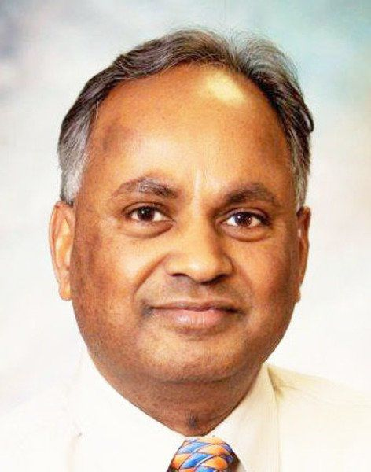
Ansari
The Hospital Medicine is a new medical phenomenon that which has taken wide acceptance throughout the world. It is a new phenomenon that has a spread throughout the United States as well. It is the fastest growing specialty in the history of medicine. There are more than 50,000 hospitalists working in approximately 75 percent of the United States hospitals according to latest reports.
The hospitalists are mostly general internal medicine physicians catering to the needs of all acutely ill hospitalized patients. This is patient specific program which brings uniformity to patient care in the hospital. Emphasis is on efficiency in treating patients while providing quality care with minimum hospital costs and resources utilization.
Since the implementation of Obamacare, there is a lot of emphasis on admissions either as outpatient (observation) or inpatient. Patients not meeting criteria for inpatient admission must be admitted as outpatient (observation). Observation patients must be discharged within one to two days and cannot qualify for skilled care services. Patients treated as inpatient can qualify for skilled care services only if certified by therapists of the need. The hospitalists do not provide any outpatient services nor do they take care of any nursing home or skilled care patients.
There have been numerous large scale studies done showing effectiveness of the hospitalist program. Research has proven that hospitalist programs reduce the length of the stay, treatment cost and improves the overall efficiency of care for the hospitalized patients.
The credit for the hospitalist program in Clinton goes to Donna Oliver, former CEO of Mercy Medical Center whose determination and vision got the program started in February 2008. Initially there was some resistance on part of many physicians about this program. Family physicians were easily convinced along with some independent physicians in Clinton to give up their in-hospital practice.
Medical Associates internists and specialists who were board certified in their specialties continued in hospital patient care for many years. They gave up admission to hospitalists last year but assuming care the next day for continuity of care. Now, only hospitalists do all admissions to the hospital for all physicians until they are discharged. After discharge, they follow with their regular physician. The specialists are available for consult and providing care in their own area of expertise.
The hospitalist program is the future of medicine that needs to be accepted by the physicians and patients alike. It is the new phenomenon in medicine that has forced physicians to adapt to new norm, mostly for the better.
Dr. Anis Ansari is the President Elect-Mercy Medical Staff in Clinton.

